Used DataBase H2 in Memory.

Previously created Treatment Plans:

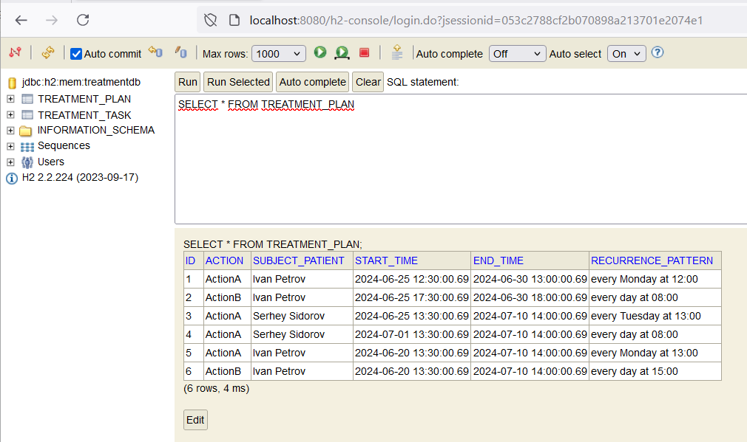

Generated Tasks in table for date June 02 2024:

